**American Bone Health**

Objective: Use the 300 rule to make something teachable, interactive, memorable and fun.

Empowering teens to take charge of their health, we first help them to determine whether their typical diet consists of a recommended intake of calcium. Through the activity, our aim is to help teens be conscious of calcium-fortified foods when deciding what to eat.

-------

How many servings do you have of the following per day?

-------

Your daily intake (IS BELOW//MEETS) the recommended daily allowance!

SKELETON GRAPHIC

Maybe something like this bar:

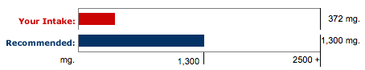

What can you do about this? // Keep it up!

-------

Remember the CALCIUM RULE OF 300!

*CALCIUM RULE OF 300 spinning animation

Let’s go through it together.

-------

1. Ask yourself: do I eat a well-balanced diet?

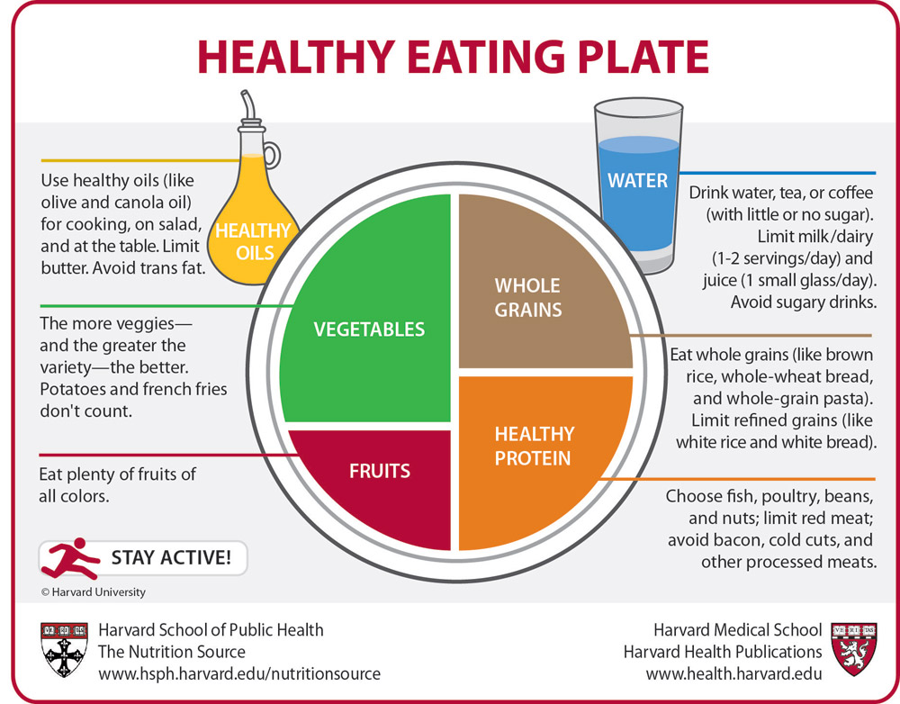

If yes, give yourself 300 points!

------

2. Ask yourself: How many cups of dairy or fortified juices do I have each day?

GRAPHIC: popping up animation 1..2..3.. milk glasses/orange juice

For every cup, give yourself another 300 points!

------

3. Add your scores in Steps 1 and 2.

Graphic: Balanced diet? + 300 x cups of milk/juice =

If you are less than 1300 points, you may need a calcium supplement!

-------

Calcium supplement.

What’s that?

Tablets that help reach your recommended daily allowance.

It is important to consume calcium daily and meet your requirement.

What happens when you don’t?

Your body will take calcium from your bones and over time, your bones become weak!

-------

Keep up with your calcium to stay strong!

GRAPHIC